**Customer Awareness**

L&T Finance Limited (“**the Company**” or “**LTF**”) in compliance with RBI’s Clarification on Prudential norms on Income Recognition, Asset Classification and Provisioning pertaining to Advances dated November 12, 2021 (“**RBI IRACP Norms Clarifications**”) as amended from time to time and /or as required/ directed by RBI, shall classify and notify facility as overdue, SMA/NPA. Further upgradation of such accounts shall also be guided by the aforementioned clarification.

Below is the manner in which such classification and upgradation will be undertaken by the Company.

* Date of overdue:

Account will be flagged as an **overdue account if as on running day-end processes (**irrespective of time of running such process)no payment has been received.

**Example for date of overdue:**

If **due date** of a loan account is **March 31, 20\*\***, and full dues are not received before the Company runs the day-end process for this date, the **date of overdue** shall be **March 31, 20\*\***.

* Special Mention Account (SMA) and Non-Performing Asset (NPA) classification:

The Company will flag an account as **SMA or NPA** if the default subsists (as per timeline prescribed) at time of running **its day-end process**.

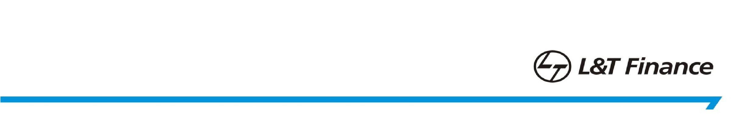The classification parameter as provided in RBI IRACP Norm Clarifications are as follows:

|  |  |  |  |
| --- | --- | --- | --- |
| Loans other than revolving facilities | | Loans in the nature of revolving facilities like cash credit/overdraft | |
| SMA Sub- Categories | Basis for classification – Principal or interest payment or any other amount wholly or partly overdue | SMA Sub- Categories | Basis for classification – Outstanding balance remains continuously in excess of the sanctioned limit or drawing power, whichever is lower, for a period of: |
| SMA-0 | Upto 30 days | SMA-0 | - |
| SMA-1 | More than 30 days and upto 60 days | SMA-1 | More than 30 days and upto 60 days |
| SMA-2 | More than 60 days and upto 90 days | SMA-2 | More than 60 days and upto 90 days |

**Example:**

**SMA-1 Classification:**

In continuation of above example, if the account remains overdue upon running **April 30, 20\*\*** day-end process it will be classified as **SMA-1.**

**SMA -2 Classification:**

Similarly, if the above account remains overdue upon running **May 30, 20\*\*** day-end process it will be classified as **SMA -2.**

**NPA Classification:**

Aforementioned account if remains overdue upon running **June 29, 20\*\*** day-end process it will be classified as **NPA.**

* Upgradation of accounts classified as NPAs

Once account is classified as NPA, it shall **only be upgraded** as standard asset upon payment of **entire arrears of interest and principal by the borrower** at the time of running the day-end activity of that particular date**.**

Existing instructions as specified for accounts classified as NPA due to restructuring, non-achievement of date of commencement of commercial operations (DCCO), etc shall continue to be applicable.

* Case study:

|  |  |  |  |
| --- | --- | --- | --- |
| **Sr.**  **No** | **Date** | **Particular** | **Remarks** |
| 1. | June 30, 20** | Non-payment at the time running day-end process. | Date of overdue |
| 2. | July 30, 20** | Non-payment subsists at the time of running day-end process. | Account to be classified as  SMA-1 |
| 3. | August 29, 20** | Non-payment subsists at the time of running day-end process. | Account to be classified as  SMA-2 |
| 4. | September 28, 20** | Non-payment subsists at the time of running day-end process. | Account to be classified as  NPA |

Account classified as NPA shall only be upgraded to standard once the all-previous dues including interest and payment are received by the Company.